**Assignment 4 – Git** :

Created 4 branches – master, public1, public2 and private respectively. And created the relevant files under it.

Merging public1 and public2 branches onto master branch.

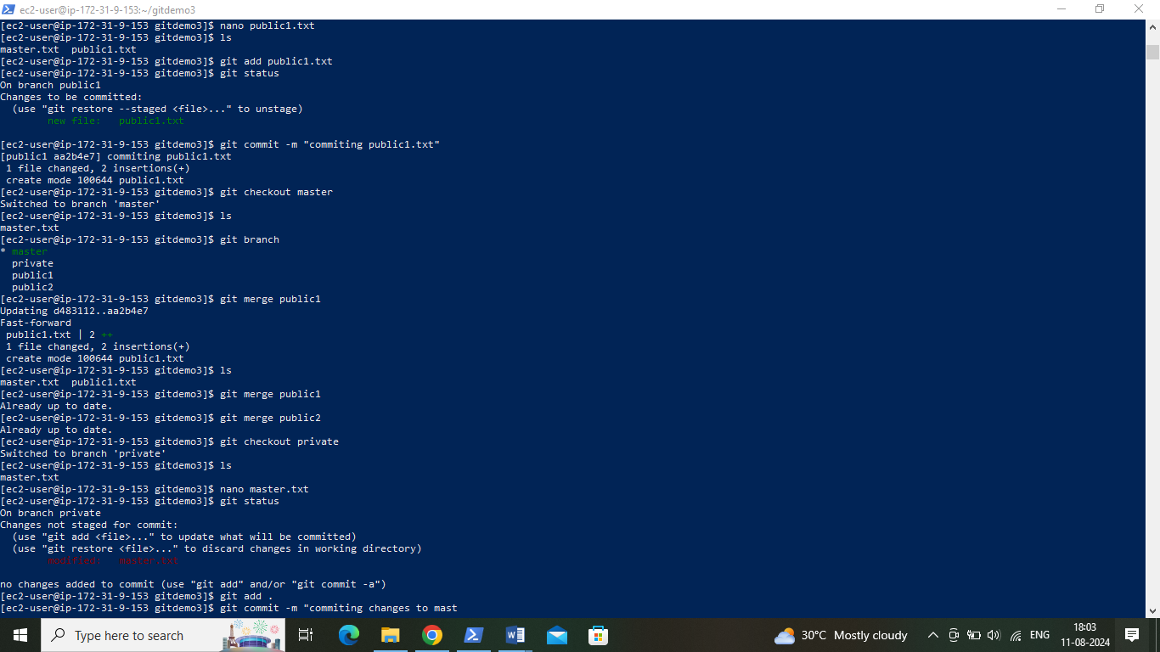

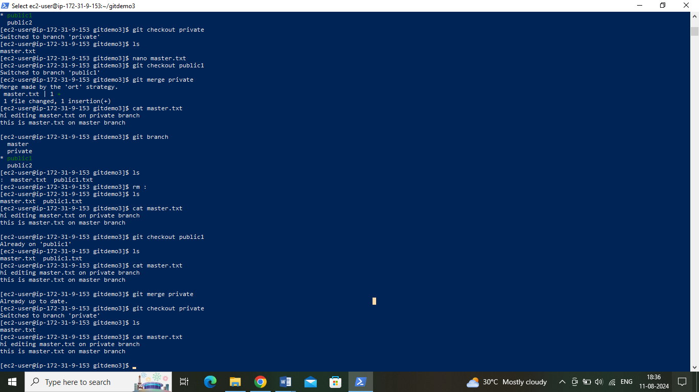

Merging (changes to master.txt file on private branch) to public2 branch :

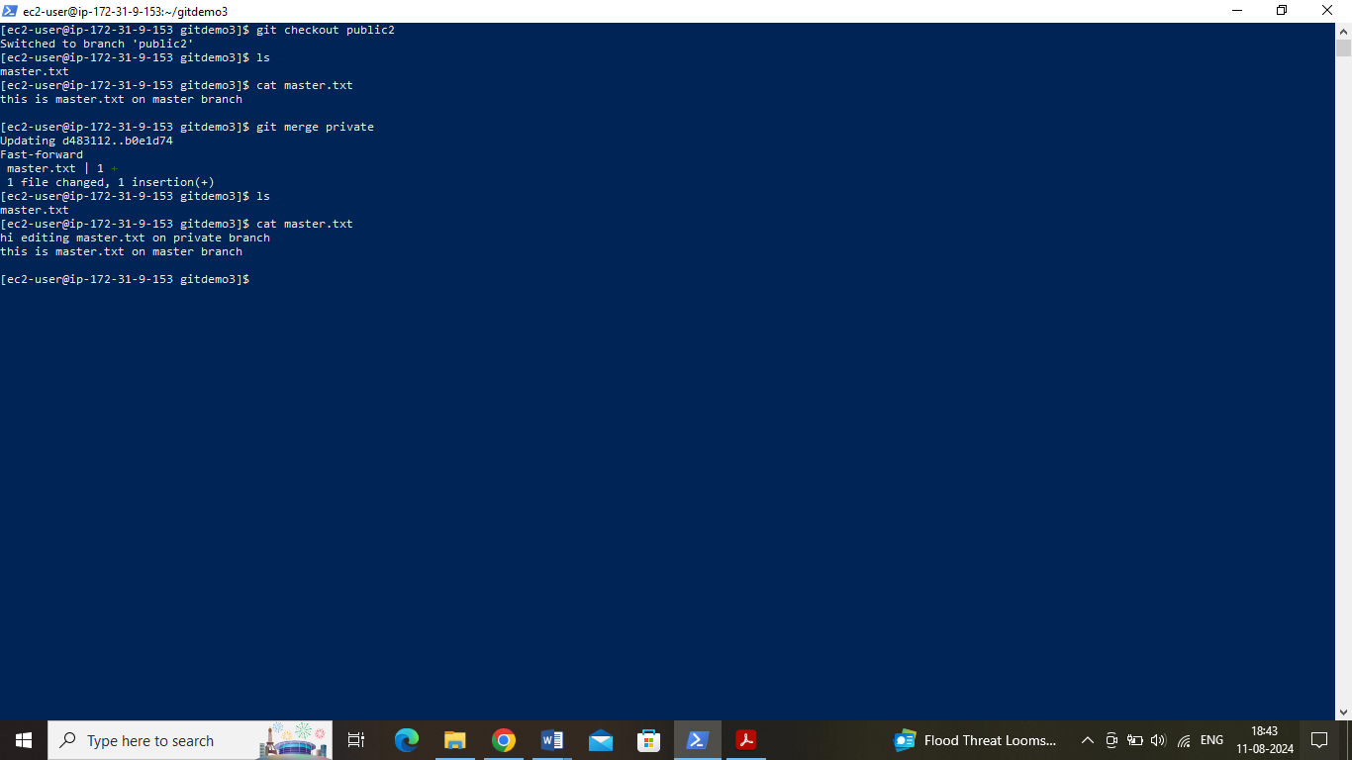

Merging (changes to master.txt file on private branch) to master branch :

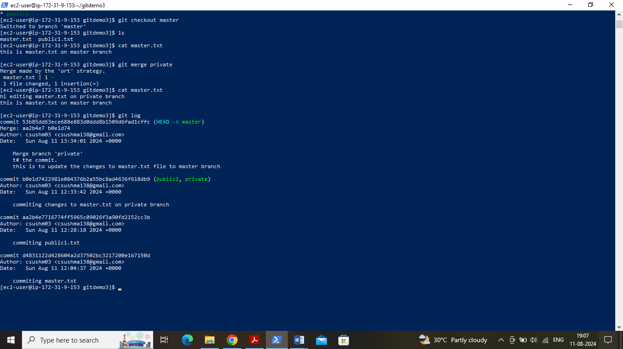

Finally merging all these changes to private branch :

